Input:

$\frac{dy}{dx}$ = $\frac{2y}{x}$

Output:

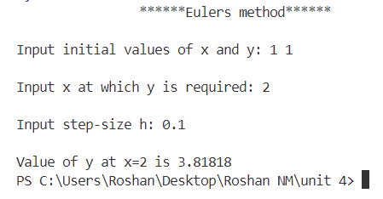

Input:

$\frac{dy}{dx}$ =3𝑥+ $\frac{y}{2}$

Output:

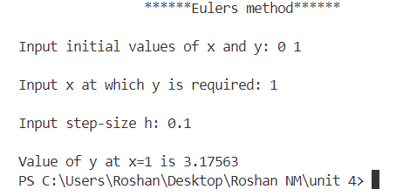

Input:

$\frac{dy}{dx}$ = $\frac{2y}{x}$

Output:

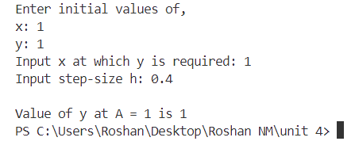

Input:

$\frac{dy}{dx}$ = 2xy

Output:

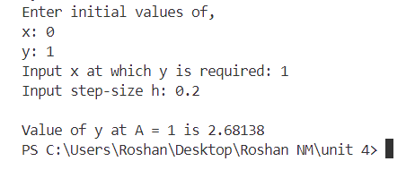

Input:

y′ = 𝑦𝑐𝑜𝑠

Output:

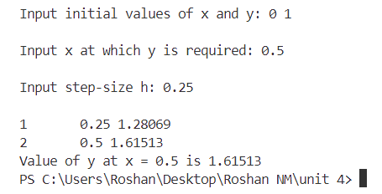

Input:

𝑦′ = 𝑥+𝑦

Output:

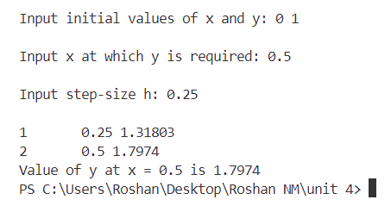

Input:

$\frac{dy1}{dx}$ =𝑥+𝑦1+𝑦2, $\frac{dy2}{dx}$ =1+𝑦1+𝑦2

Output:

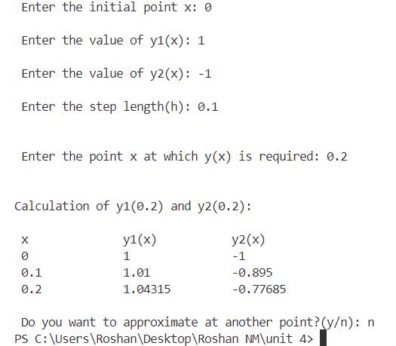

Input:

= 𝑦1𝑦2 + 𝑥2 +1, =𝑦2+ 𝑥𝑦1 + 𝑦1

Output:

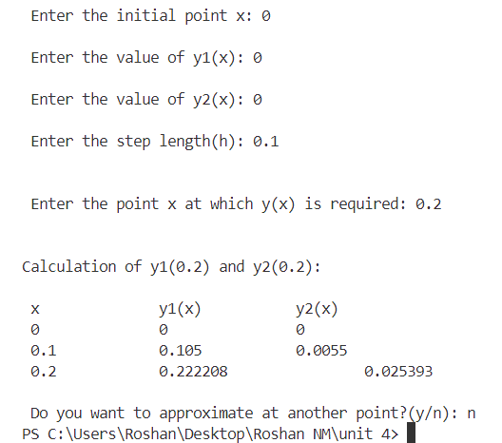

Input:

+ 2 $\frac{dy}{dx}$- 3y = 6x

Output:

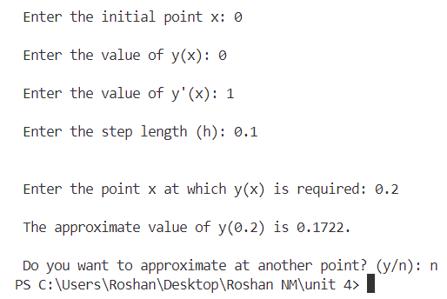

Input:

+ 4 $\frac{dy}{dx}$ + 5y = 8x

Output:

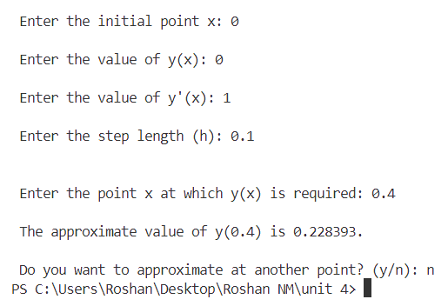

Input:

= 2 x2 y + 1

Output:

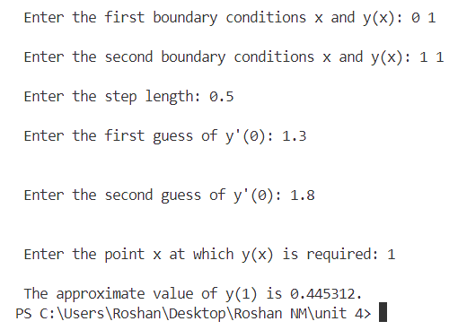

Input:

= 4 x3 y + 2

Output:

